**Project Planning Phase**

**Project Planning(Product Backlog, Sprint Planning, Stories, Story points)**

|  |  |
| --- | --- |
| Date | 22 October 2022 |
| Team ID | PNT2022TMI26539 |
| Project Name | Smart Fashion Recommender Application |
| Maximum Marks | 8 Marks |

**Product Backlog, Sprint Schedule, Estimation**

|  |  |  |  |  |  |  |
| --- | --- | --- | --- | --- | --- | --- |
| Sprint | Functional Requirement | User Story | User Story / Task | Story points | Priority | Team Members |
|  | (Epic) | Number |  |  |  |  |
| Sprint-1 | Setting up App |  | As a user, I can register in ICTA |  |  | Santosh V |
|  | environment | USN-1 | Academy and create IBM cloud account. | 2 | High | Pratheev j |
| Sprint-1 |  | USN-2 | As a user, I will create a flask project | 1 | Low | Sachin pj  Srivarshan R |
|  |  |  |  |  |  | Santosh v |
| Sprint-1 |  | USN-3 | As a user, I will install IBM Cloud CLI | 2 | Medium | Sachin Pj |
|  |  |  |  |  |  | Pratheev j |
| Sprint-2 | Setting up App environment | USN-4 | As a user, I can install Docker CLI | 1 | Low | Srivarshan R |
| Sprint-2 |  | USN-5 | As a user, I will Create an account | 2 | Medium | Pratheev j |
|  |  |  | in sendgrid |  |  | Santosh V |

|  |  |  |  |  |  |  |
| --- | --- | --- | --- | --- | --- | --- |
| Sprint-3 | Implementing web | USN-6 | As a user, I Create UI to interact | 1 | High | Santosh V |
|  | application |  | with the application |  |  | Sachin pj |
| Sprint-3 |  | USN-7 | As a user, I Create IBM DB2 and connect with Python | 3 | High | Pratheevj |
| Sprint-3 | Integrating sendgrid | USN-8 | As a user, I will integrating sendgrid | 2 | High | Srivarshan R |
|  | service |  | with python code |  |  |  |
|  |  |  | As a user, I have to build a chatbot |  |  |  |
| Sprint-3 | Developing a chatbot | USN-9 | and Integrate to application | 1 | Medium | Santhosh V |
| Sprint-4 | Development of App in | USN-10 | As a user, I will Containerize the | 1 | Low | Sachin pj |
|  | IBM Cloud |  | App |  |  |  |
|  |  |  | As a user, I will upload image to |  |  |  |
| Sprint-4 |  | USN-11 | IBM Container registry | 2 | Medium | Pratheev j |
|  |  |  | As a user, I will deploy App in |  |  |  |
| Sprint-4 |  | USN-12 | Kebernetes cluster | 3 | High | Pratheev j |
|  |  |  | As a user |  |  | Sachin pj |
| Sprint-4 | User panel |  | ● Register, Login, Email, |  |  | Santosh v |
|  |  |  | Verification | 3 | High | Pratheev j |
|  |  |  | * Manual Search * Order placement, Order   Details |  |  | Srivarshan R |

**Project Tracker, Velocity & Burndown Chart**

|  |  |  |  |  |  |  |
| --- | --- | --- | --- | --- | --- | --- |
| Sprint | Total Story | Duration | Sprint Start Date | Sprint End Date | Story Points | Sprint Release Date |
|  | Points |  |  | (Planned) | Completed (as on  Planned End Date) | (Actual) |
| Sprint-1 | 18 | 6 Days | 24 Oct 2022 | 29 Oct 2022 | 24 | 29 Oct 2022 |
| Sprint-2 | 18 | 6 Days | 31 Oct 2022 | 05 Nov 2022 | 24 | 05 Nov 2022 |
| Sprint-3 | 18 | 6 Days | 07 Nov 2022 | 12 Nov 2022 | 24 | 12 Nov 2022 |
| Sprint-4 | 18 | 6 Days | 14 Nov 2022 | 19 Nov 2022 | 24 | 19 Nov 2022 |

# Velocity

Imagine we have a 6-day sprint duration, and the velocity of the team is 18(points per sprint). Let’s calculate the team’s average velocity (AV) per iteration unit (story points per day)

AV = Sprint Duration / Velocity

AV=24/6=4

# Burndown Chart

A burn down chart is a graphical representation of work left to do versus time. It is often used in agile software development

methodologies such as Scrum. However, burn down charts can be applied to any project containing measurable progress over time.

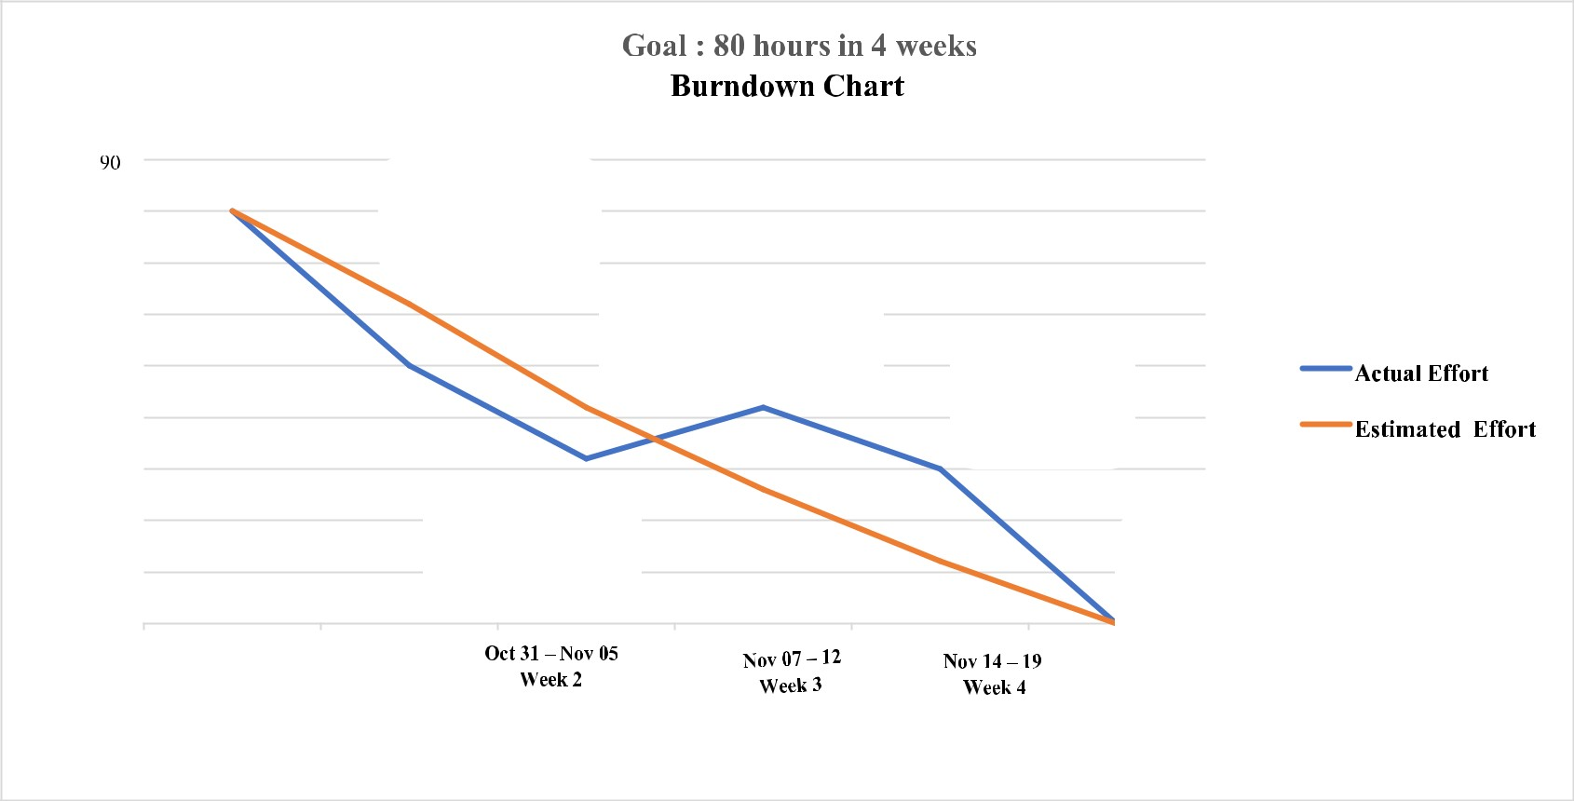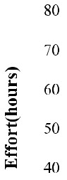

Setting up App

Environment

Integrating sendgrid

service

Developing

a chatbot

Implementing

Deployment of

web App

app in IBM Cloud

**Oct 24**

**-**

**29**

**Week 1**